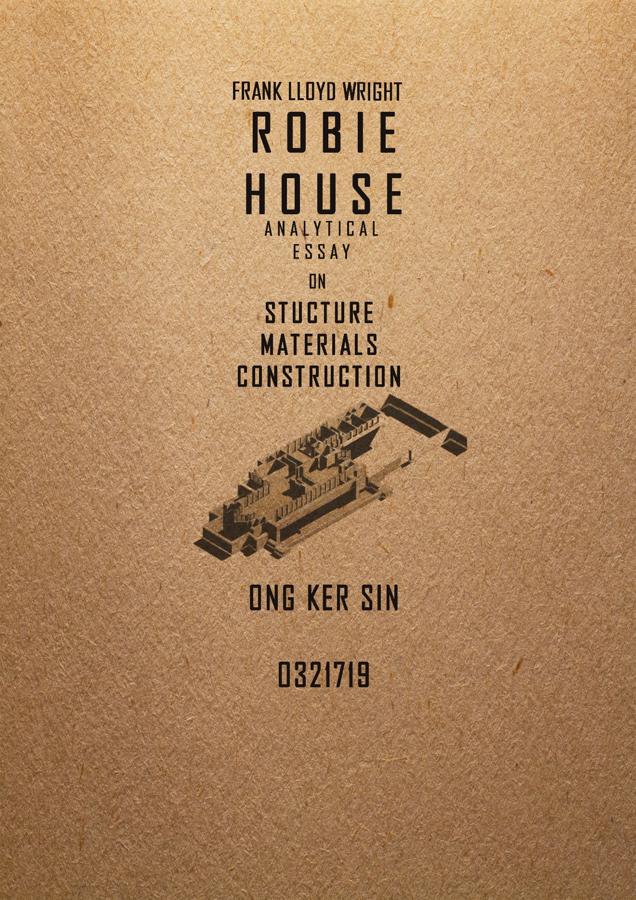
Throughout this paper, I am going to compare the works of Frank Lloyd Wright and Ludwig Mies Van der Rohe in the materials they used and the methods of construction for their buildings.
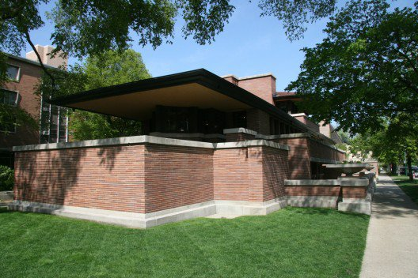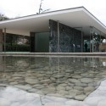
Robie House Barcelona Pavilion
Photo: Nat Hansen Photor:gondolas
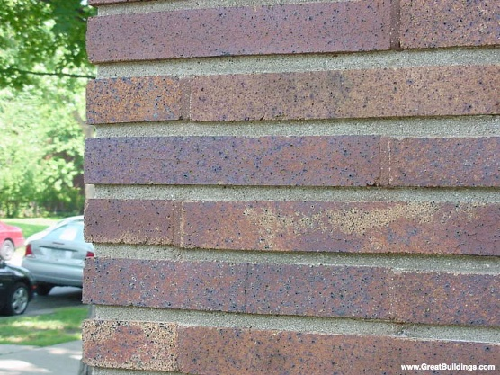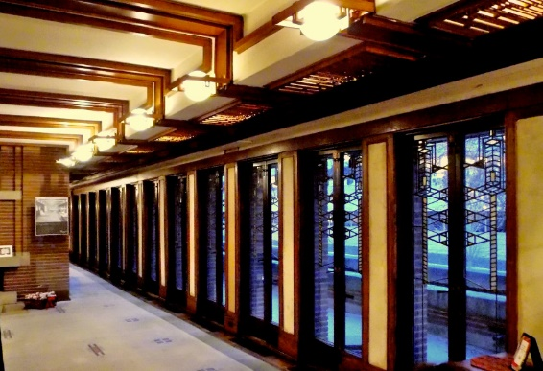
Roman Brick Art Glass
Photo: Robie Residence · Chicago, Illinois Photo: Andi Marie/Chicago Patterns 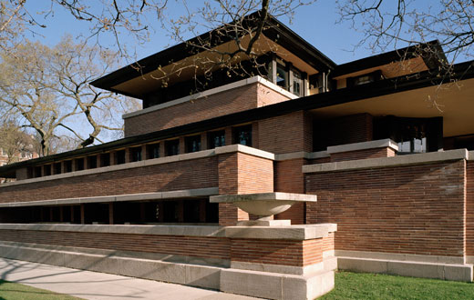 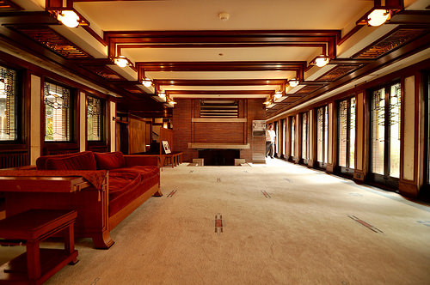
Limestone Water Table Oak
Photo: Dees Stibling Photo: Lloydnalex
"Simplicity is not plainness. Simplicity leads to clarity in design. To know what to leave out and what to put in, and just where to put it, is something that comes from the knowledge of simplicity." This belief influenced Wright’s choices in materials and details. From a visual perspective, the Robie House consist of four basic materials that are the limestone used for the water table and the copings, the Roman bricks used on the exterior, the oak used in the furnishings as trim and lastly the glass which serves to keep out the wind and rain at the same time to let more natural lights in to the inner spaces (Emerson).
The stone used is light in color was to contrast with the Roman bricks and also to combine with the long cantilevered roof lines and to emphasize the horizontality of the house. Besides, the steel beams that act as structural supports were only supporting the overhangs and the floating brick balcony. The exterior walls are double-Wythe construction of a Chicago common brick core with a red-orange iron-spotted Roman brick veneer. The horizontal joints were filled with a cream-colored mortar and the small vertical joints were filled with brick-colored mortar to further emphasize the horizontality of the bricks and minimize the appearance of individual bricks (Whinfrey, 2010).
As for the steel beams in the ceilings and floors, they carry most of the building's weight to piers at the east and west ends. As a result, the exterior only have some contribution in supporting function. The steel structure also has a role of eliminating the need for internal structural columns and walls, creating an open and flexible plan Wright favored in his Prairie style. Thus the exterior walls are filled with openings like doors and windows containing art glass panels. With this exception, exposed oak was to soften the interior spaces and to help giving them scale as well.
Wright felt that glass was the most precious of the architect’s new materials. It minimized the distinction between inside and outside and it created the sense and feeling of bringing outside inside as Wright favored. Besides, more natural lights can be penetrated in to the inner spaces that allowed people to visually or even mentally escape from the darkness that had dominated their dwellings in the past. Through his use of materials, Wright achieves a remarkable balance of tone and color, this is because the iron-flecked brick he used in this house harmonizes with the iridescent leaded art glass of the windows that encircle the entire building.
Mies van der Rohe believed in “less is more”. Mies van der Rohe clearly explained and practiced this maxim throughout his buildings. He had a passion for finding the simplest form of proportion, details and structures. A great example of this passion of this is the Pavilion in Barcelona.
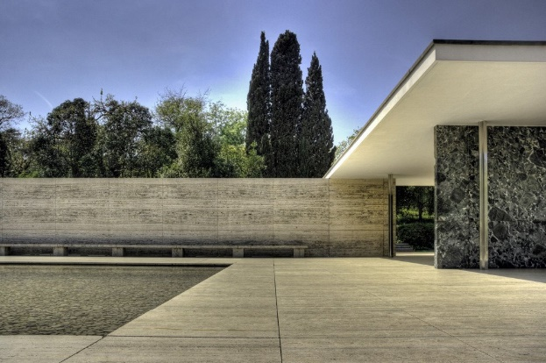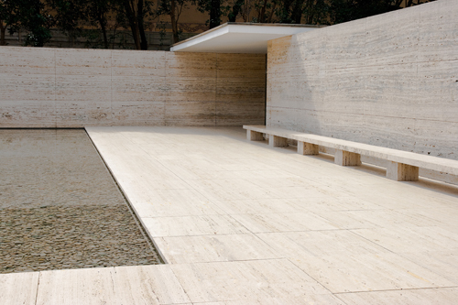
Exterior Travertine
Photo: wotjek gurak Photo: Meta Musings
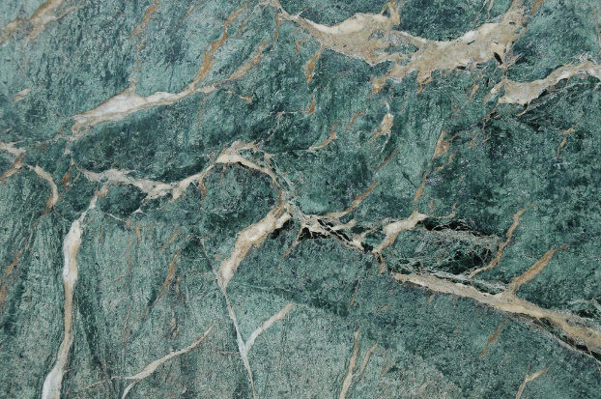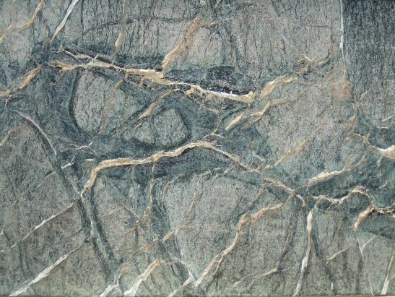
Green Alpine Marble Green Greece Marble
Photo: Tom Consgrave Photo: Tom Consgrave
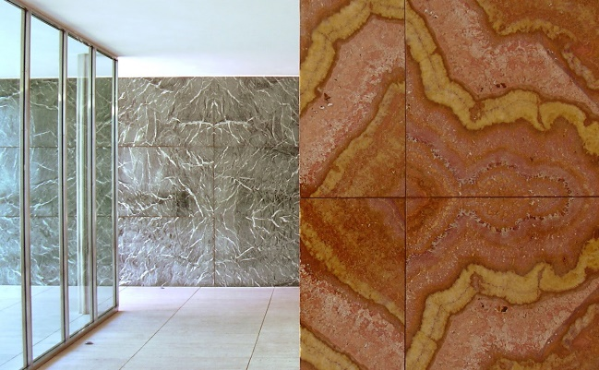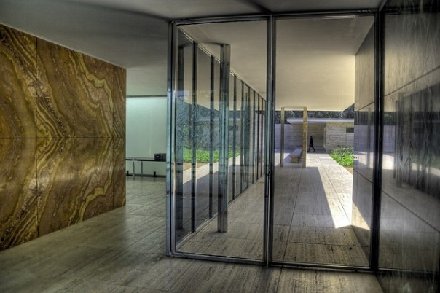
Golden Onyx Glass
Photo: designacademia Photo: designacademia
In the Pavilion, there are four different types of marbles were used in the Barcelona pavilion that are Roman travertine, green marble from the Alps, old green Tinos marble from Greece and onyx from the Atlas (Soa-Morales, Cirici, Ramos, 2000). Roman travertine provided by the Berlin Company of Ko-stner und Gottschalk was used for the exterior walls and the paving of the pavilion. The travertine paving was laid in square slabs measuring approximately1.10 x 1.1. m. While the travertine of the vertical walls had a double dimension of roughly 2.20 x 1.10 m, the walls were being based on a double slab of 3cm thick with a load-bearing metal structure in its interior (Soa-Morales, Cirici, Ramos, 2000). This was also the system used for the walls of green marble from the quarries of Alps and also the Greek mainland. The green Alpine marble was used in the long, three-sided wall which enclosed the outer part of the small pool. While the free wall by the main access steps at the entrance to the interior of the Pavilion was of the green marble from Tinos.
However, of the different types of stone used, the most famous type is onyx dore which Mies purchased from a Hamburg marble merchant. This onyx was used in the free-standing central wall of the Pavilion’s roofed space. This figures produced by the onyx with its brilliant and diffuse coloration and its great dimensions in slabs of 235 x 155 x 3 cm, made this naturally rich material to be more powerful and interesting than any sculpture in the flow of circulation through the Pavilion’s interior (Soa-Morales, Cirici, Ramos, 2000). There are several types of glass with different colors and grand dimensions being used in the Barcelona Pavilion as well. For example, there are clear, bottle green, mouse grey and milky white or sand-buffed glasses and the various transparent and translucent finishes that established contrasts with one another as they enclosed the limits of a single space.
However, due to some economic reasons, the catalogue of the materials envisaged for the building was cut down, in some cases at the last minute. In the case of the glass and onyx, replacements were kept in hand to make good any breakages. As for green Alpine marble and travertine, the quantities ordered were reduced. As a result, the exterior side walls and the rear part of the Pavilion were not clad with these materials but with ordinary bricks, plastered and painted green and yellow to make them resemble to the intended materials. After looking at the materials used in the Barcelona Pavilion, we understand that the effect of modernity and pure technology by Mies in this Pavilion consisted not so much in the newness of the materials but in the audacious manner of their combination and the technically way they were used for large surfaces and simple, elemental geometric forms (Soa-Morales, Cirici, Ramos, 2000).
For my opinion, the concept that have been applied in both of this buildings are the “simplicity”. Although they are both using the concept of simplicity, but the way they interpret in their buildings are different. For the Robie House by Frank Lloyd Wright, the simplicity is in the sense of materials used in the house. The entire house is sheathed by the Roman bricks as to enhance the simplicity of the house without using any other extra materials. As for Barcelona Pavilion by Mies, the simplicity could be proven by the building that no ornamentation has been used in it. “Less is more” by Mies was emphasized on less ornamentation in the building, thus the Pavilion was only built by slabs of marble and glass that support the roof without adding any other ornamentations inside. The materials are simple but luxurious, instead of ornamentation. Besides, the originality of Mies lay not much on the modernity of the materials but on how they manage and to make the materials express as an ideal of geometry (Soa-Morales, Cirici, Ramos, 2000).
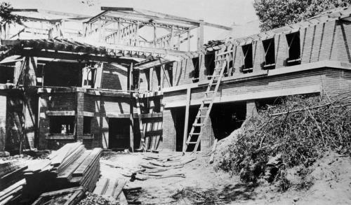
Construction of Robie House
Photo: Chicagogeek
For the construction part of the Robie House, it was built on foundation with concrete footings below grade without any foundation walls. As for the exterior walls which were built by using the Roman bricks have the dimension of 5 x 30 cm with cream-colored mortar to fill the joints (Snelling, Rebecca, 2007). As for the structural system of the house, the steel I’s and channels have been used to support the house. The exterior decks are reinforced concrete supported on steel while the interior floors are wood joist construction bearing on steel. The wide projecting eaves are framed with principal members of steel with wood rafters resting on the steel. These channels are visible from access hatches in the soffit at the west end of the living room.
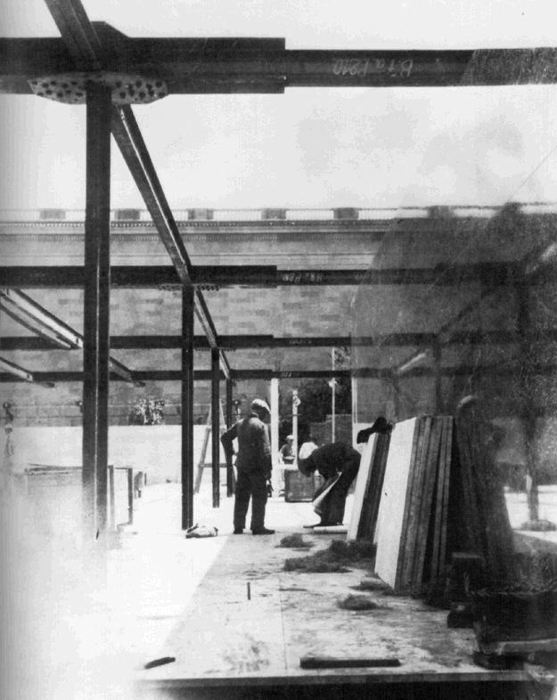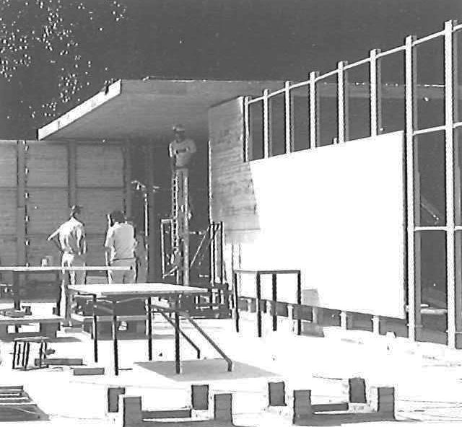
Construction of Barcelona Pavilion
Photos: Mies Van Der Rohe: Barcelona Pavilion
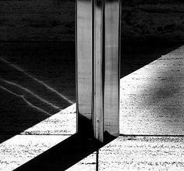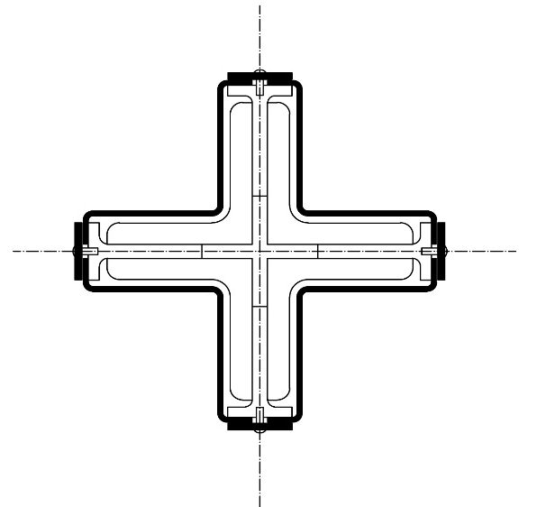
Photo: Juan Judel Photo: liuzuorange
The construction of the podium base of Barcelona Pavilion employed the Catalan vault which is a small vault built of brick, plastered on the narrower side that allowed the construction of self-supporting surfaces without the use of scaffolding (Soa-Morales, Cirici, Ramos, 2000). The foundation system was extremely superficial that it based on a perimeter ditch filled with solid concrete as a support for the iron beams on the vaults rested longitudinally and to the pillars that were anchored at appropriate points. The load-bearing structures of the wall and the two planes of the roof were based on a framework of standard-section laminated steel beam. This framework consisted the steel beam that has four angles forming a cross, defining the eight pillars bearing up the roof of the Pavilion. On top of these eight pillars there was a framework of steel beams with a depth of 210mm which was to have formed the grid for the horizontal support of the roof (Soa-Morales, Cirici, Ramos, 2000).
The similarity between these two buildings is that the steels were used as supportive structure to support the house instead of using the walls as load-bearing structures. But as in the Robie House, the steel structures used were hidden. On the other hand, for the Barcelona Pavilion, we can still see total of eight metal-clad columns exposed in the Pavilion. The columns act as the supportive columns to support the slabs of roof of the Pavilion. The expression of the Pavilion was abstracted and simplified.
After studying the two buildings, I found that they are both completely opposite styles from architecture of each other in the general sense, but both were in the modern area that have some similarities. The fact is that they both have a desire for oneness by using different materials and methods of construction to complete them.
(Word counts: 1686)

References
Alexander von Vegesack, Matthias Kries (Ed.). (1998). Mies van der Rohe : architecture and design in Stuttgart, Barcelona, Brno. Vitra Design Museum.
Carter, P. (1927). Mies Van Der Rohe at Work. Phaidon Press.
Ford, E. R. (2011). The Architectural Detail. New York: Princeton Architectural Press.
Heinz, T. (2002). Frank Lloy Wright's Houses. America: Grange Books.
Ignasi de Sola-Morales, Cristian Cirici, Fernando Ramos (2000). Mies Van Der Rohe Barcelona Pavilion (5th ed.). Spain: Editorial Gustavo Gili, SA.
Rebecca Snelling, Jan Suermondt (2007). Frank Lloyd Wright Revealed. Chartwell Books.
Robert, M. (1999). Frank Lloyd Wright. Phaidon.
Emerson, R. W. (n.d.). The Robie House. Retrieved from http://www.oocities.org/soho/6252/finaldraft.html
Erins, J. (n.d.). Frederick C. Robie House. Retrieved from http://lcweb2.loc.gov/master/pnp/habshaer/il/il0000/il0039/data/il0039data.pdf
Frank Lloyd Wright trust (n.d.). Frederick C. Robie House. Retrieved from http://www.flwright.org/researchexplore/robiehouse

Perez, Adelyn. (n.d.). AD Classics: Frederick C. Robie House / Frank Lloyd Wright. Retrieved from http://www.archdaily.com/60246/ad-classics-frederick-c-robie-house-frank-lloyd-wright/

Whinfrey, D. (n.d.). Robie House. Retrieved from http://www-personal.umich.edu/~dwhin/ARCH211/1_2_dwhin.pdf

