

ENVIROMENTAL SUSTAINABLE DESIGN
BLD60203T0539-M

PROJECT 1: NATURE AND US
REFLECTIVE ESSAY

THE INDUSTRIAL HAZARDOUS WASTES

TUTOR: MISS SUJAH
STUDENT NAME: NG MING HWEE 0319511
ONG KER SIN 0321719
SIM JIA HUI 0320386

Nowadays, large number of wastes that are hazardous or toxic being produced due to the development and improvement of the economic and the people’s life standards and those wastes have been released to our environment. There are many sources where the hazardous and toxic chemicals come from. For example, toxic wastes released from factories for the purposes of research & development and manufacturing & importing purposes as well. Besides, storage, transportation and disposal may cause the release of hazardous and toxic substances or chemicals too. There are risks associated with their uses in all these fields. Those toxic substances being released as the by-product of industrial activities. In developing countries, the release of industrial hazardous waste is increasing due to the speedy growth in economic development and urbanisation. Therefore, it leads to the issues of management and also some noticing impacts. Crucial or serious impacts would have happened not only to the humans but also to animals and the most importantly our environment. Those industrialized countries are responsible for this environmental degradation. These countries are now in a position to control local situation by implementing stringent standards, by applying different economic instruments.
This world is increasingly producing and releasing those hazardous wastes into our environment. Of course there are some regions that are severely polluted by the released of these hazardous wastes. So, which region generated most of the hazardous wastes in this world? Instead of looking only into the regions in the world, we might have to study and analysis the condition in our country, Malaysia as well. Which state in Malaysia that has been produced the highest number of hazardous wastes? Why are they producing this much of wastes? And also how do they manage the disposal of these hazardous wastes. In addition, we will also look into how those released hazardous wastes affect our environment. As an architect, this is our responsible to consider about our environment when we are designing buildings. The buildings must be sustainable so that to save our environment. All of us are the habitant of this planet, this environment, so we have the right and responsibility to know what happens around us. Also, this is our responsibility to help and solve this problem or issue from getting worse.

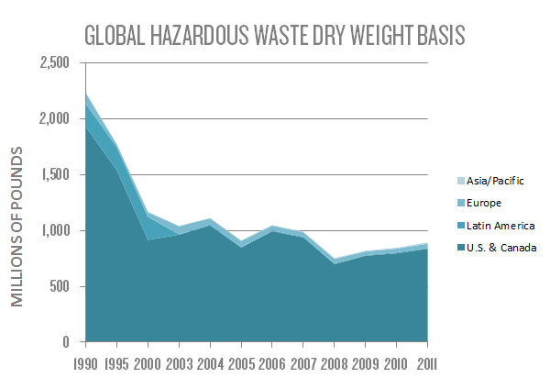

Data from: Dupont SHE- Global Hazardous Wastes
Figure 1
First, we have to take a look at the contemporary condition of the producing and releasing of hazardous wastes in some specific regions in the world. So, we have searched some data about the released of hazardous wastes in Asia/ Pacific, Europe, Latin America and also U.S. & Canada. As we can see from Figure 1 above that Asia/ Pacific have the most released hazardous wastes compared with the other regions. This is because Asian countries in Asia Pacific Region are the fastest growing countries in the world due to its faster industrialization rate, and international trade. Therefore, Asian countries produced the highest amount of hazardous wastes as compared to the other regions in the world. But unfortunately, Malaysia is one of those Asian countries, and it means that Malaysian had been producing hazardous wastes in the amount that is considered as huge. In Malaysia, 30% of hazardous waste is generated from electroplating and metal industries. Many products that are related to the built environment could be produced from this electroplating and metal industry, for example nuts that have been widely used for furniture in the buildings, door knobs that must be included whenever there’s a door in a building and also electroplating of the buildings’ roof.
As we know that Asia or Pacific has been the regions that produced most of the hazardous wastes that are threatening our environment. So we think that financial problem is always with all the countries to implement effective environmental pollution control system in those industries especially with the small scale industries in Hong Kong, Malaysia, Papua New 6 Guinea, and Philippines, who prefer to shut down the operation rather than installation of individual hazardous waste treatment facilities. In our opinion, it could be much more effective if those industries could install or implement some effective environment pollution control system. The amount of hazardous wastes could be reduced as well as the products could be produced without causing serious effects to human or even our environment.

Data from: Asia Pacific Workshop on Global Partnership on Waste Management
Figure 2
What is an industrial hazardous waste? Toxic or hazardous wastes are poisonous by products of manufacturing, construction, automotive garages and so on. The wastes can be in liquid or solid form or even sludge that contains chemicals, heavy metals, radiation or other toxins. There are various types of hazardous wastes like dross/ash, gypsum and mineral sludge which are the most produced hazardous wastes in our country, Malaysia. The dross that has been produced is the residual waste product during aluminium melting process. There are approximately 36446 metric tons of dross were produced in the year of 2013. The reason why aluminium dross is produced in such high quantities in Malaysia is because aluminium is a material commonly utilized in the production of a number of products including pistons, engine and body parts for cars, beverage cans, doors, siding and aluminium foil. We could see from Figure 1 that Malaysia has been producing 30% of hazardous wastes from electroplating and metal industries, therefore dross would be the hazardous waste that has been produced in the highest amount in Malaysia. It is closely related to our built environment because dross is the hazardous waste product from the aluminium melting process which is required in manufacturing doors and also aluminium foils as heat insulation materials in buildings.
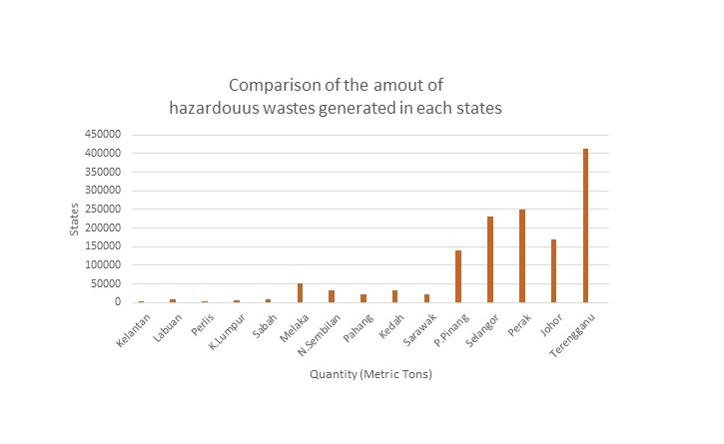
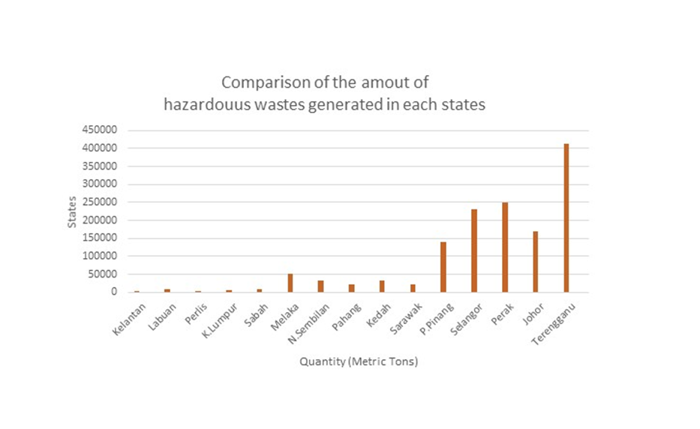
As we mentioned earlier dross is the hazardous waste that has been generated in the mass production of aluminium. One of the uses of the aluminium production is for the making of doors in buildings. In our opinion, dross has been producing in such amount from the aluminium melting process is because that dross is recyclable. Besides, aluminium will be generated in a large amount is because of its much lighter than steel and quite durable. But the problem with the aluminium melting process is that it requires large amount of energy and this energy is generated by using natural gas. It would generate more hazardous wastes as well as deplete the natural resources on the earth. So, for the energy production, we should have considered about using renewable resources like wind and solar energy instead of those that are non-renewable. With this, it would produce less hazardous wastes and also could save our environment.

Data from: Asia Pacific Workshop on Global Partnership on Waste Management
Figure 3
After looking into the type of hazardous wastes that has been produced in the largest amount in Malaysia. Now we are going to look into which state in Malaysia that produced hazardous wastes in a mass amount. In Malaysia, Terengganu has released the most hazardous wastes as compared with the other states follow up by Perak and Selangor. Terengganu used to be Malaysia's poorest state until oil and gas were discovered off its coastline not too long ago. Therefore, Terengganu will be categorized as the state that has generated large amount of hazardous wastes is because that the petroleum and gas have become the main industry of the state. The examples of petroleum and gas that are related to the built environment are detergent which is used to wash clothes in daily life, synthetic fibres for curtains/ carpets/ rope/ everyday clothing and also the most importantly the paint that is needed for most of the buildings in Malaysia. From Figure 2 and Figure 3, we can see the relation between the production of petroleum and gas with the dross which is the hazardous wastes released into our environment in a huge amount. The dross will be produced as hazardous waste product during the aluminium melting process. As in this process, petroleum and gas would be required to heat and melt the aluminium into liquid form. This is the reason why dross would be generated in such a large amount and Terengganu would become the state in Malaysia that released hazardous wastes in a huge number.
Terengganu became the state that generated hazardous wastes in a large amount. As a result, its industry of petroleum and natural gas have contributed to the aluminium melting process which produced dross as hazardous waste product in a huge quantity. Both of these industries cause a lot of harms to our environment and nature. Therefor we suggest that instead of using petroleum and natural gas as the raw materials in most of the processes especially the aluminium melting process, we should have considered about using renewable energy sources like wind and solar energy. As we know that Terengganu is located along the coastline at north-eastern Peninsular Malaysia, wind and sunlight are easy to get so that to produce energy which cause no harm and effect to our environment. It would become much more sustainable if the use of petroleum and natural gas could be changed into using wind and solar energy. Moreover it could reduce the hazardous dross during the aluminium melting process as well because the materials used to produce heat are renewable and therefore creating less hazardous wastes into our environment.
Next we are going to look into the industries that have produced and generated hazardous wastes in Malaysia. Malaysia's industrial sector accounts for 36.8%, over a third of the country's GDP in 2014, and employs 36% of the labour force in 2012. The industrial sector that generated hazardous wastes mostly contributed by the electronics industry, automotive industry construction industry, oil and gas industries and the others. Therefore, we can’t agree more that the environmental issues that are happening nowadays due to hazardous wastes production are all because of these industries. As we mentioned earlier, Terengganu has become the state that produced hazardous wastes in a large amount due to the petroleum and gas industry. Therefore, oil and gas industry is believed to be the major sector that caused a huge amount of hazardous wastes to be generated and produced.
Besides that, electronics industry has contributed to the hazardous wastes in our environment as well. There are many electronic devices that are related to our built environment and are used in our daily life like air-conditioner, refrigerator and so on. As in this case, we could solve this problem by implementing some environmental effective methods when we are designing buildings. For example, we could undergo a site analysis at first before designing a building so that to understand more about the weather, climate or the atmosphere at the site. With the information we get from the site analysis, we could design the building to be more environmental sustainable. The works by Philippe Rahm, principal in Philippe Rahm Architects that is based in Paris are very good examples for environmental sustainable designs. Philippe Rahm has developed a practice which fabricates environments based on their climatic and physiological aspects. As a result of that, we should have practised the same design concept so that to create atmosphere that is comfortable inside the building and to avoid from using air-conditioner because it is considered as one of the source of the hazardous wastes.

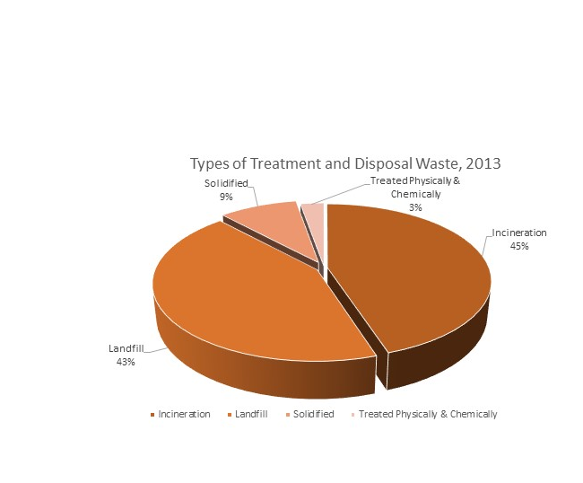

Data from: Asia Pacific Workshop on Global Partnership on Waste Management
Figure 4
There are many ways and choices for the management of the hazardous wastes generated. Some of the hazardous wastes will be reused and recycled if possible. For those that cannot be reused or recycled will be safely stored, transported and properly disposed of to prevent accidental release into the environment. But the manufacturer nowadays will not be considering about the way to manage the hazardous wastes because their purpose is to earn money but not to save the environment. There are some typical methods of hazardous waste storage and disposal including surface high temperature incineration (controlled burning), municipal and hazardous waste landfills (burying it in the ground), solidified and also physically/ chemically treatment. But, there are some more promising methods focus on minimizing waste, reusing and recycling chemicals, finding less hazardous alternatives, and using innovative treatment technologies.
As we can see from Figure 4, the management of hazardous wastes by incineration is mostly used in Malaysia with a percentage of 49%. This is because this method requires minimum land and can be operated in any weather. But to manage those hazardous wastes by using incineration and also landfill disposal, it would require large lands for the operation of the management. In the other words, these managements are depleting the natural resources to manage the disposal of those hazardous wastes. It would bring negative effects to our environment as well. For example, the incineration process produces two types of ash. Bottom ash comes from the furnace and is mixed with slag, while fly ash comes from the stack and contains components that are more hazardous. In our opinions, we think that recycling would be the best way to manage the hazardous wastes and it is they key in providing a liveable environment for the future.

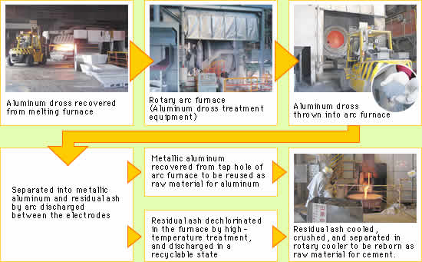
Source: Handbook of Advanced Industrial and Hazardous Waste Treatment
Figure 5
We have mentioned earlier that dross is the hazardous waste production during the aluminium process. Dross, although a hazardous waste but it contains aluminium and other valuable elements like aluminium bauxite as well ,it is a very good example of hazardous waste that can be managed by recycling it as shown in Figure 5. In addition, there are some other promising methods that will not be affecting or harming our environment like reducing the hazardous wastes production. For example the petroleum and gas industry in Terengganu should have considered this method so to reduce the hazardous wastes produced during the process. They could change the production methods, substitute less toxic materials, segregate wastes or even delist the wastes that do not have hazardous characteristics because these are some technique that are most common in industrial hazardous wastes minimization programs.
All the scheduled wastes (hazardous wastes) is managed by the Department Of Environment in Malaysia. The site recovery facilities waste must to be licensed for safety and other important reasons. If we look back to the days in the year of 60s, the emphasis had been put on the development of industries in Malaysia during those decades. The rapid growth in industry resulted in the huge generation of hazardous and scheduled wastes. The condition that time was worsens because of the lack of effective and compatible facilities to handle and manage the waste and the uncontrolled hazardous waste threatening the public health that time. Our government has realized the importance of this serious issue so there are many rules and policy like the Policy Guidelines on Handling , Storage ,Transport and Disposal of toxic and Hazardous Wastes was set up in 1983 and DOE handed in the proposal of the National Strategy for the management of Toxic and Hazardous Wastes in 1984.
In 1995, Kualiti Alam Sdn.Bhd was authorised the special right to carry out the facilities for all the process in treating and disposing wastes. But the agreement between government and Kualiti Alam has ended in 2015 Feb. Besides, there are legislations that have been set up to restrict and confirm the hazardous wastes to be well managed. Moreover, there are some amendments to EQA 2012 including the reward to informers, Section 49 B, the power of arrest without warrant ,Section 37C(1) and etc. The government also provided incentives like tax rebates to industries to adopt clean technology to promote the recovery and reutilization of waste. And we hope that the committee to be transparent when they carry out their duty in examine of the wastes generator and the licensed scheduled site recovery facilities.
With the helping hand from the government policies, the wastes management will be well treated .Every session in the management of these scheduled wastes should follow the guidelines given by government tightly. The build of the site recovery facilities is helpful in the build of environment. The wastes should have a particular and respective place to go, not dumping directly to the environment but being managed optionally depending the conditions and to take our environment as the main reason. Furthermore, if the facilities are located adjacent to the industrial area which will be generated a large amount of hazardous wastes, then the area must be clearly zoned to protect the other habitants nearby from getting affected. When the residential area and the commercial area nearby, where there are high population in, the habitants will be less affected by those hazardous wastes generated or released, these areas will be more sustainable for the people and their future generations.
In most of the countries in Asia Pacific regions, the waste is directly dumped in open land, or natural watercourse, and ocean causing surface and groundwater pollution. There are many unidentified contaminated lands in this region. Moreover, transportation of hazardous waste from developed countries would cause land and water pollution as well. Those hazardous wastes can harm humans, animals and even plants if they encounter with these toxins buried in the ground, in stream runoff, groundwater that supplies water or even in floodwaters. Hazardous wastes can contaminate and create threats to human health and environment when they are released into the air as well. Contamination of hazardous wastes in water will cause harmful effects on people and also affect aquatic organisms including fish. Fish are known to accumulate hazardous metals from water and fish living close to mining site have higher concentration of hazardous metal. Hazardous wastes contamination will affect the food web as well as causing indirect consequences for fish species. As we mentioned earlier, Terengganu is located along the coastline of Peninsular Malaysia. As a result, it would definitely affect the ocean life there due to its popular petroleum and natural gas industry. In addition, hazardous wastes which are dumped in improper sites can seep into underground water supplies and contaminate huge areas. If the land that is intoxicated supports plant life, most of the plants and trees will die off.
Lack of expert manpower for such activities is one of the main reasons for the contamination of hazardous wastes. In some of the regions, industries are still throwing the hazardous waste in environment and increasing the area of contaminated sites. There are some cases of accidental release of toxic materials in environment and continue the contamination, constant and consistent release of oil although in smaller quantities from carrying ships, trucks and rail cars. For example, the 1995 discovery of 41 drums of toxic potassium cyanide dumped by a small chemical trading firm on Pangkor Island, Malaysia. As a result, we think that it is really important to have expert manpower to in charge of the release of hazardous wastes in environment. They could release the hazardous wastes after treatment to reduce its toxicity to us and also our environment. If the waste is treated by storing in containers, they have to make sure that the waste will not be leaking out as it would contaminate the ground there. Lack of strict authority and less public awareness are causing problems of hazardous wastes contamination as well. The most importantly is to be careful and concern during the treatment of hazardous wastes no matter what method that has been used, it’s our responsibility to protect the environment from getting destroyed.
Here is a very good example about incident about hazardous wastes being released to the environment with residential area nearby happened in Bukit Merah, Bukit Merah, Malaysia, June 26, 2012 - Thirty years have passed since Japan's Mitsubishi Chemicals opened a rare-earths refinery in the Malaysian village of Bukit Merah, but although the plant is gone, its toxic legacy persists. The facility was embraced by authorities as an advanced foreign investment that would help create jobs in poor Perak state in the country's north. But a rise in leukemia and other health problems has left the site, now abandoned, as a silent warning to Malaysia as it touts a controversial new foreign rare-earths plant being built in the country's east by Australia's Lynas corp. Corp
Malaysia. Lynas Corporation, Ltd. is an Australian rare earths mining company that has two major operations, a mining and concentration plant at Mount Weld, Western Australia and a refining facility at Kuantan. The reason why they will be taking those rare earths all the way from Australia to Malaysia and process them here is because Australia cannot provide high-skilled manpower and that Australia cannot supply enough water, acids and natural gas to process them. The people in our country are strongly opposing the operating of Lynas in Malaysia as the valuable rare earths will be extracted and exported to US, Europe and Japan, leaving behind those harmful substances there. From the date that our Prime Minister approved this project, there were several campaigns have been held to stop and prevent this from launching. Fatal results have been caused from this incident and this is such an unforgettable pain in the memories of the inhabitants there. Incident of Bukit Merah has given the huge attack to us and we have learnt a lesson about the danger of hazardous wastes to us or even the environment from this tragedy. 30 years have passed, it is time for us to question whether if we can really accept this to be happened again.
This refining facility entered production in 2013, producing 1,089 tonnes of rare earth oxides in the first quarter of 2014, with a target of 11,000 tonnes per annum. Most rare earth metals are harmless, but in natural ore rare earth is normally mixed with the radioactive substances. These radioactive substances release radiation and two major toxic materials that are radon gas and lead. These rare earths are used in many products in the built environment like televisions and fluorescent or energy-saving lamps. As in this case, we have known the serious effects that Lynas has brought to us and the environment. So, we suggest to use other materials that are more environmentally friendly than the rare earths in order to prevent more hazardous wastes to be produced and released into the environment. For example, we could choose other company’s products rather than Lynas’s that would require to release large amount of hazardous wastes into the environment. As we can see how much hazardous they will be producing in such a short term and imagine how serious the habitants nearby and the environment have been affected and destroyed. Although the launching of Lynas will be bringing a lot of benefits to our country in terms of economics, but we have to consider about the health of people and the importance to protect the environment before anything else.
In conclusion, the effects of hazardous waste production in our environment are one of the growing concerns in most of the developing countries. This is more important for those countries of transition that they only concentrate their activities on rapid industrial growth. Disposal of hazardous wastes no matter it’s purposely or even accidentally has caused both short term and long term effects in the environment. The identification of the problem and the implementation of the solution is a step by step process, which should be started in time to prevent further contamination or harmful effects of hazardous wastes to our environment. Last but not least, this is our responsibility to protect our environment to prevent it from getting destroyed or harmed. So it is important for us, the future architects to be really concerned about our environment condition and so to design buildings that are environmental sustainable as a result of saving the environment.

References
Clapp, J. (2001). Toxic Reports: The Transfer of Hazardous Wastes from Rich to Poor Countries.
Hassan, D. H. (October 2014). Schedule Waste Management in Malaysia & The Way Forward. Retrieved from http://myservices.miti.gov.my/documents/48027/87409/14_gos_wksp1_007_Presentation%20DOE%20Malaysia.pdf

Global Hazardous Waste. (n.d.). Retrieved May 8, 2015, from http://www.dupont.com/corporate-functions/our-approach/sustainability/commitments/goals-progress/articles/global-she-performance/global-hazardous-waste.html Hazardous Wastes -
Sources Of Hazardous Wastes. (n.d.). Retrieved May 8, 2015, from http://science.jrank.org/pages/3232/Hazardous-Wastes-Sources-hazardous-wastes.html
J. Glynn Henry, Gary W. Heinke (1996). Environmental Science and Engineering (2nd ed.). Prentice Hall, 1996.

Lawrence K. Wang, Yung-Tse Hung, Nazih K. Shammas (Ed.). (2009). Handbook of Advanced Industrial and Hazardous Wastes Treatment. Taylor & Francis.
Lessons from Bukit Merah. (n.d.). Retrieved May 30, 2015, from http://www.freemalaysiatoday.com/category/opinion/2012/03/21/lessons-from-bukit-merah/
Manahan, S. E. (2004). Environmental Chemistry (8th ed.). Taylor & Francis.
Visvanathan, C. (n.d.). Hazardous Waste Management in Southeast Asia. Retrieved from http://www.faculty.ait.ac.th/visu/pdfs/Activities/Participation/HWMSA.pdf

(n.d.). Retrieved May 29, 2015, from http://myservices.miti.gov.my/documents/48027/87409/14_gos_wksp1_007_Presentation DOE Malaysia.pdf

